Chinese Nationals Overview
Sideboard Staff
Over the last twenty years, China has come a long way, transforming itself from a closed, Communist society to a burgeoning center of trade and industry. She has survived the "Asian economic flu" of 1998, achieved normal trade relations with her Asian neighbors, Europe, and the United States; and is knocking on the door of the World Trade Organization. China has finally taken its place as one of the leading "Asian Tigers."
For the last two years, Magic: The Gathering and the DCI have been along for the ride. In 1998, the Chinese government recognized Magic as an "Exhibition Mindsport." In 1999, Chinese players got their first taste of international competition when a Chinese exhibition team competed in the team-day at Worlds in Yokohama. For 2000, China enjoyed its first Regionals in Beijing, Shanghai, and Chengdu; followed by its first full-fledged National Championship. The People's Republic will send a team to fully participate in the World Championship in Belgium from August 3-8.
But things are just a little different here. For example, China has not received new sets on the same schedule as the rest of the World. This has had an impact on tournament formats. Fortunately, the situation will change this fall, when Invasion becomes the first set to release to Chinese players at the same date it is offered to other players around the world.
Another difference is that PRC committees exclusively manage membership in all organizations, even sporting and gaming clubs. Rules for tournaments, competitions, and judges are actually written into the laws of China. This means that the DCI must work in cooperation with a branch of the government, the Chinese Sports-For-All Athletic Committee (CSAAC) in order to run tournaments. Fortunately, CSAAC and the DCI independently arrived at many of the same standards regarding competition, and the behind-the-scenes alliance is mostly transparent to all players.
Despite the differences, Magic players are Magic players everywhere you go. With limited access to outside deck tech, most of the standard archetypes have developed here. Local versions of Stompy, Draw-Go, and "Sped-Red"-style land destruction are all found in the decklists of Regionals and Nationals. The recent title events have brought players from different parts of the country together to compete and compare notes for the first time. A Chinese website devoted to tournament news and strategy, www.linglong.com, has even sprung up, hosted by a retailer in Shanghai. They may still be new to drafting, and their play style may be a little free-wheeling, but Chinese players are ready to take the next step up to serious competition.
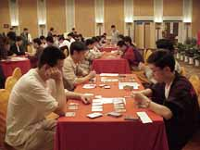  34 Competitors square off in the first draft pods of day 1 | 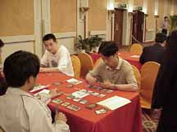  Chen Li Xue, Shanghai
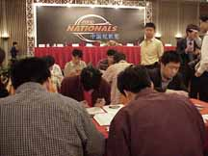  Players during deck construction 1, stage in background | 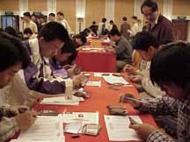  Since Mercadian Masques was not released in Chinese Simplified (CS), players were allowed to use translated spoiler lists during deck construction after each draft (visible in the middle of the table on the left)
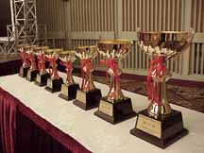  Top 8 trophies on display | 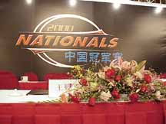  Close up of stage
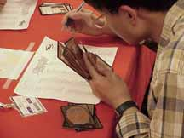  Deck registration in another language and alphabet is tough | 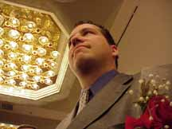  Joe Hauck, Magic Brand Manager
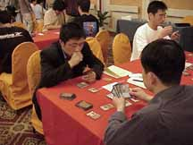  Jiang Yan, Beijing | 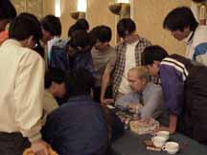  Peter Adkison gunslinging
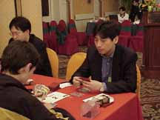  Xu Jian Hua, Shanghai, 1st place after draft day | 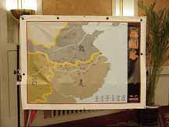  Happy Three Kindoms Tournament (actual name): A Heaven for new players
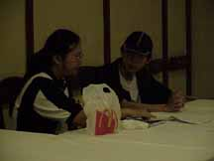  Head Judge Jacky Yang (LIII, Taiwan) reviews test results with a prospective judge. McDonald's is the official food of Magic tournaments everywhere. | 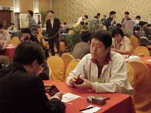  Jia Wei, Beijing, second place following the draft, top seed after Swiss rounds
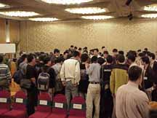  Players and cameras crowd around the final match | 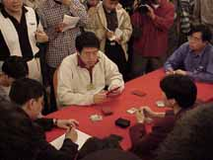  Jia Wei contemplates his initial draw
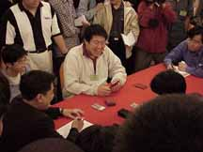  Jia Wei breaks the tension with a joke before the finals | 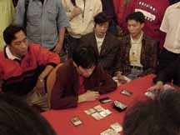  Things are looking down for Zhang Wen, finalist

Xu Jian Hua  Leader after Day 1  (6 rounds booster draft)  Draft two decklist  Creatures:  1x Chameleon spirit  1x Drake Hatchling  1x Rishadan Cutpurse  1x Rishadan Footpad  1x Sailmonger  1x Saprazzan Legate  1x Saprazzan Outrigger  2x Stinging Barrier  2x Bog Smugglers  1x Cackling Witch  1x Cateran Brute  1x Deathgazer  1x Enslaved Horror  2x Higway Robber  1x Strongarm Thug  Spells:  1x Brainstorm  1x Diplomatic Immunity  1x Dark Ritual  1x Haunted Crossroads  2x Maggot Therapy  2x Rouse  2x Snuff Out  1x Vendetta  Land:  8x Island  9x Swamp | Wei Jia  Second Place after Day 1  (6 rounds booster draft)  Draft two decklist  Creatures:  1x Alabaster Wall  1x Ballista Squad  1x Devout Witness  1x Jhovall Rider  2x Revered Elder  1x Task Force  1x Thermal Glider  1x Overtaker  2x Deadly Insect  1x Deepwood Wolverine  2x Howling Wolf  1x Hunted Wumpus  1x Rushwood Elemental  1x Rushwood Herbalist  1x Snorting Gahr  Spells:  1x Inviolability  1x Muzzle  1x Noble Purpose  1x Righteous Aura  2x Ancestral Mask  1x Briar Patch  1x Ferocity  1x Invigorate  1x Sustenance  1x Tiger Claws  Land:  11x Forest  4x Island  8x Plains

